

Digital & Social Media Analytics

A report by Paritosh Sinha PGID: 12220056

**–** An Examination of the AppleWatch Subreddit on social media



Title

**–** Apple Watch



Topic (sub group)

Introduction: Focused to the Apple Watch, the AppleWatch subreddit provides a platform for potential customers, tech enthusiasts, current users, and information seekers looking for

debates, support, and information about Apple's wearable device.

To thoroughly understand the AppleWatch subreddit, this research will look at data that has been taken from the community in order to get insights into user behaviour, sentiments,

community dynamics and advice the brand on their social media strategy based on this listening campaign.

**–**



Keywords

# Based on Title

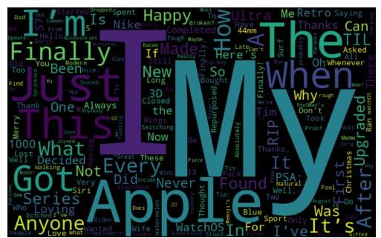

Fig 1: Word Cloud based on the data collected from subreddits Titles as provided by the users.

# Based on Combined Text (Title and Text)

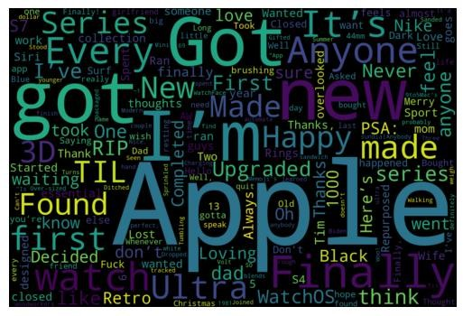

Fig 2: Word Cloud based on the data collected from subreddits Titles and text inside as provided by the users.

Most common relevant keywords surrounding the discussions around Apple watches are

Happy (To have the product), Got, new, got, Upgraded (Sign of repeat customer), Completed (Around some accomplishments of tasks), Finally (Sense of achievement), Loving, First

(which indicates first time customer), TIL (Engaging and Informed Customers) Today I’ve learned, PSA (Public Service Announcement broadcast of information of the product in the network), Found etc

Negative words like – Waiting, think, Lost, Charging, RIP, Dark, Closed, S4, S7(Series 4 and 7 of Apple Watch seems to be making the buzz) The words which are coming strong and have negativity associated with it will help us understand where as the product or as a brand apple needs to work on.

To understand these we need to do more deeper analysis and address some of the repeated issues which our customers are encountering.

**–**



Influencers

* Highest number of posts are identified by user on this topic –

egocentric-video, mumpf1997 and followed by joeledition, yugtabub, where

**egocentric-video** – user mainly talks about Apps (**Tech savvy**)

**mumpf1997** – mainly talks about My Watch and Activity (looks like he is **a fitness Enthusiast**)

**joeledition** – Bands, Accessories and My Watch

**yugtabub** – Activity, App and My Watch

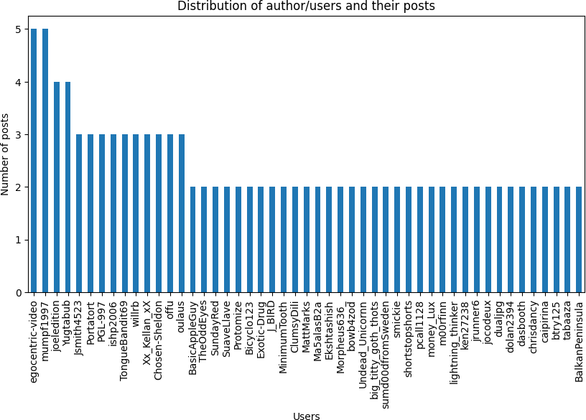

Fig 3: Bar Graph representing Number of posts made by individual users to identify Influencers and active users.

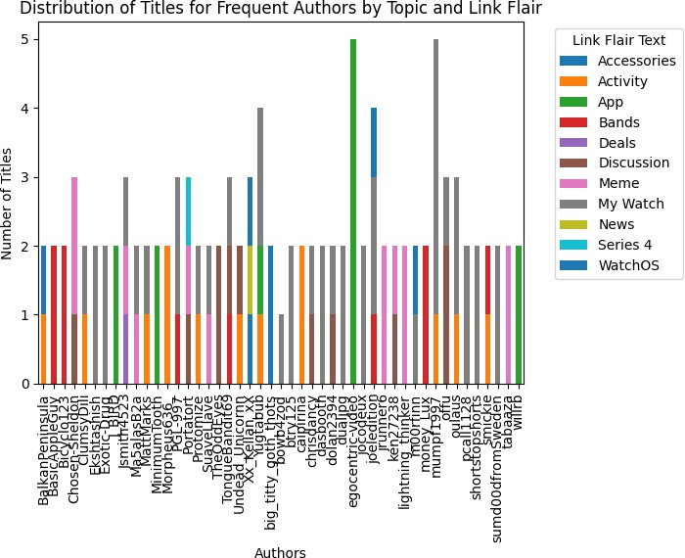

Fig 4: Bar Graph representing Number of Titles and Subclasses of Topics made by individual users to identify Influencers in particular area of expertise.

* Most active users based on their activity based on comments made by them Top 3 – egocentric-video (866 comments)

nosypumpkin(831 comments) reclusedesign(742 comments)

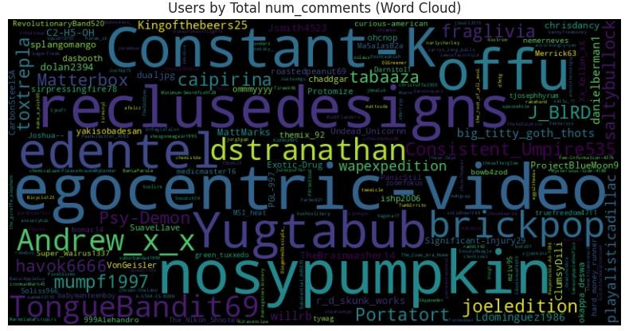

Fig 5: Word Cloud based number of comments made by users on subreddits.

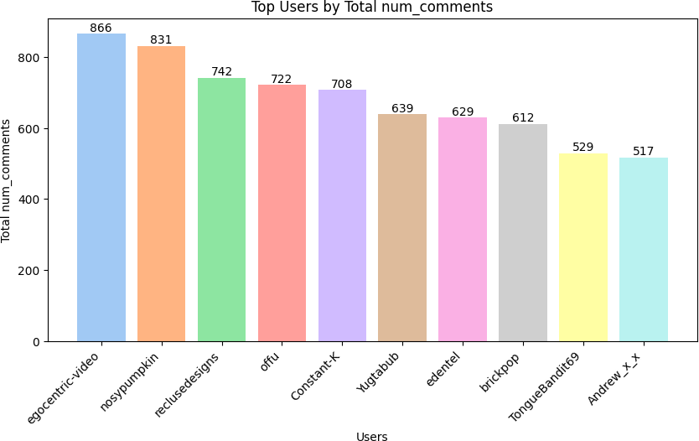

Fig 6: Bar Graph representing Users v/s Number of comments

* Top 3 users on the basis of Upvote_ratio – Xx_Kellan_xX

Scolirk

ilikebirdsthatfly

And all three have of 0.99 This is based on how other users are perceiving the contents posted by the user. As content posted by the Xx_Kellan_xX, Scolirk, ilikebirdsthatfly is liked by other users.

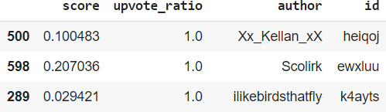

Fig 7: Table representing Normalised upvote_ratio

* Top 3 users on the basis of scores given by reddit which is based on the relevancy of the activity and comments provided –

mattmurphy00(13977)

TheBrainwasher14(11553) mnjustesen(10669)

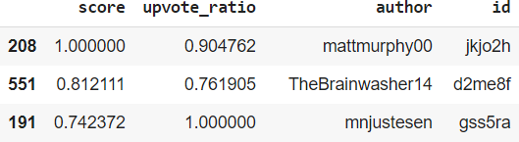

Fig 8: Table representing Normalised score

As scores given by reddit are based on an algorithm which according to Stanford

<https://web.stanford.edu/class/archive/cs/cs224n/cs224n.1174/reports/2735436.pdf> is calculated after filtering out bot-generated comments which is very necessary, as the model tends to assign high

scores to such comments.

The representative class-maximizing comments for each subreddit capture the

characteristic content and culture, reflecting topics. So, this is important to normalise the effect of such malicious factors to churn out the most authentic scores when it comes to identifying influencers.

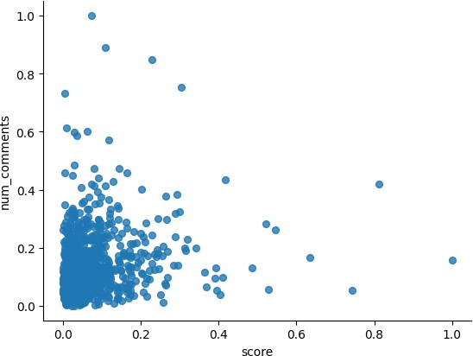

Fig 9: Scatter plot representing Normalised score vs num_comments

As this is evident that few of the posts have high score even when the number of

comments on the posts are lower. This is due to Reddit’s algorithm which internally on

various parameters weights the quality, activity, reducing the score if the post is identified as posted by bot etc.

**–**



Different Groups and Conversations surrounding the brand

Based on Sentiment surrounding the posts made by users –

I have done sentiment analysis on title, text and combined (title and text) of the posts: Observation:

**Text** is mostly Neutral as many of the post does not even have text inside it and it is just the title and text part is containing image which is not processed here.

**Title** is also representing Neutral (478) followed by Positive (388) and ¼ of the it as Negative (134)

whereas

**Combined Text** (Title + Text) is coming out as Neutral (457) followed by Positive (406) and

¼ of the it as Negative (137)

So, groups (clusters) are figured out based on the sentiments about the products.

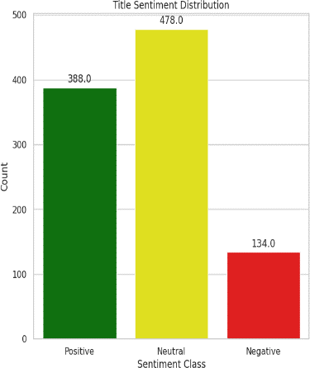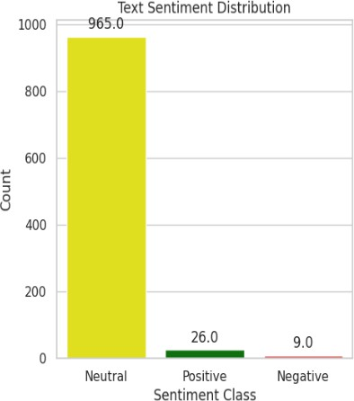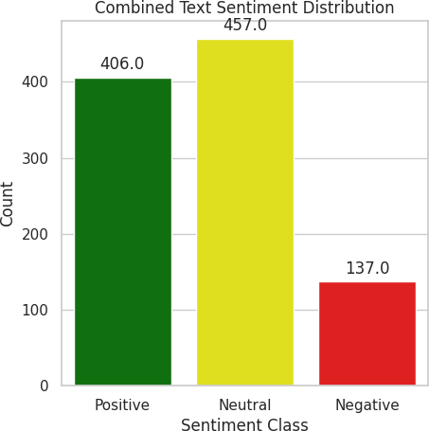

Fig 10,11,12: Bar Graph representing Sentiment distribution of the posts. It could be Positive, Negative or Neutral.

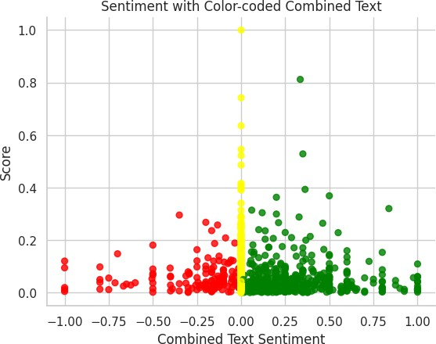

Fig 13: Scatter plot representing Sentiment distribution of the posts. It could be Positive, Negative or Neutral.

On studying the scatter plot it can deduce that negative posts are definitely there but the

magnitude of negativity is less and very few posts are very highly negative and as a brand we need should study what is making people post so much of negative content about us.

As we can do some damage control here before customer turn more negative.

Here from *fig14* we can make out that most of the discussion is done under My Watch which is the highest used subcategory are

Activity Discussion

Meme (Relating to the mockery of our product)

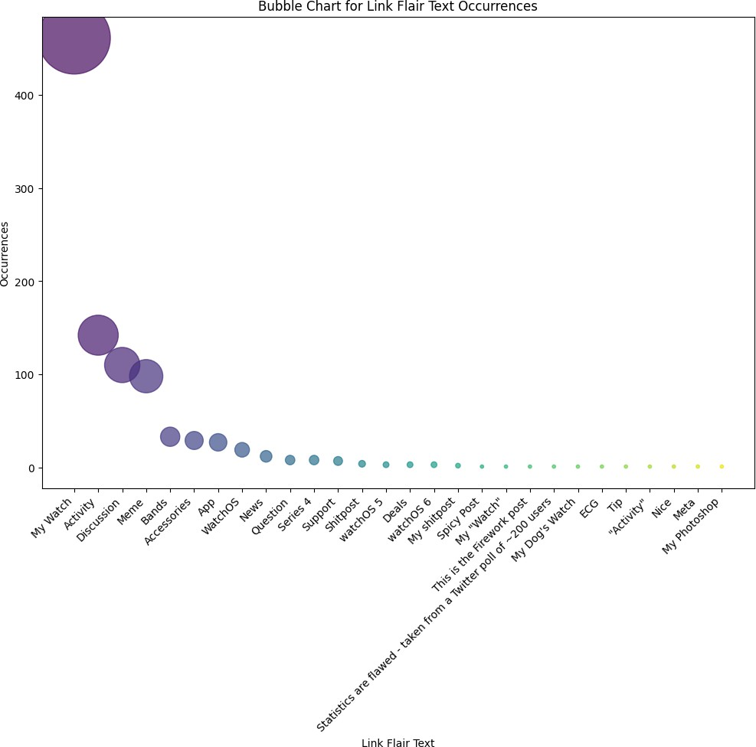

Fig 14: Bubble chart representing Intensity/ Occurrence of Subtopic (Link_flair_text) distribution of the posts

From *fig 15* below, as for the interim link_flair_text field of the reddsjit post gives some

insights about how what the subreddit address to basically the category or class the discussion belongs to like Discussion, Watch etc

On doing network analysis on Top 100 users based on scores and link_flair_text

corresponding to their subreddit posts; communities or major discussion amongst users with respect to AppleWatch is My Watch and Meme section is seem to be having the maximum traction.

Followed by Activity and Discussion surrounding WatchOS, Accessories

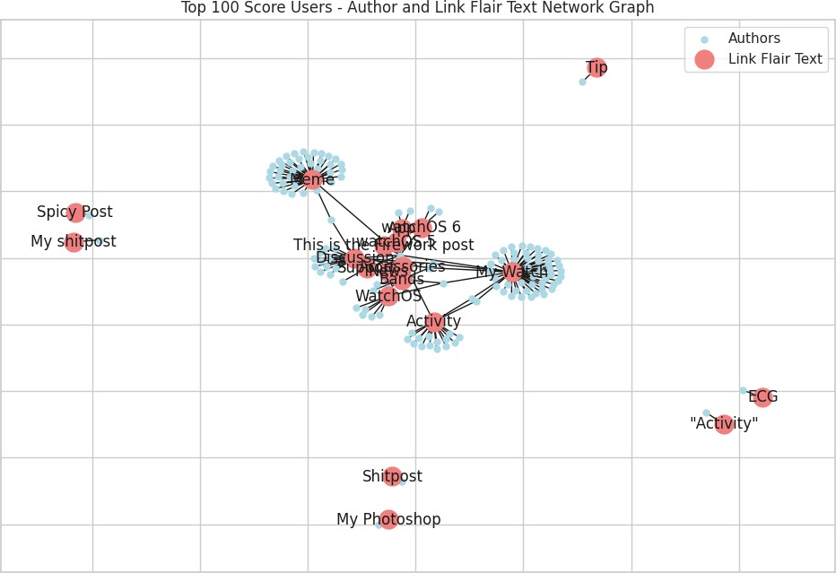

Fig 15: Network graph plot representing Intensity/ Occurrence of Subtopic (Link_flair_text) distribution of the posts

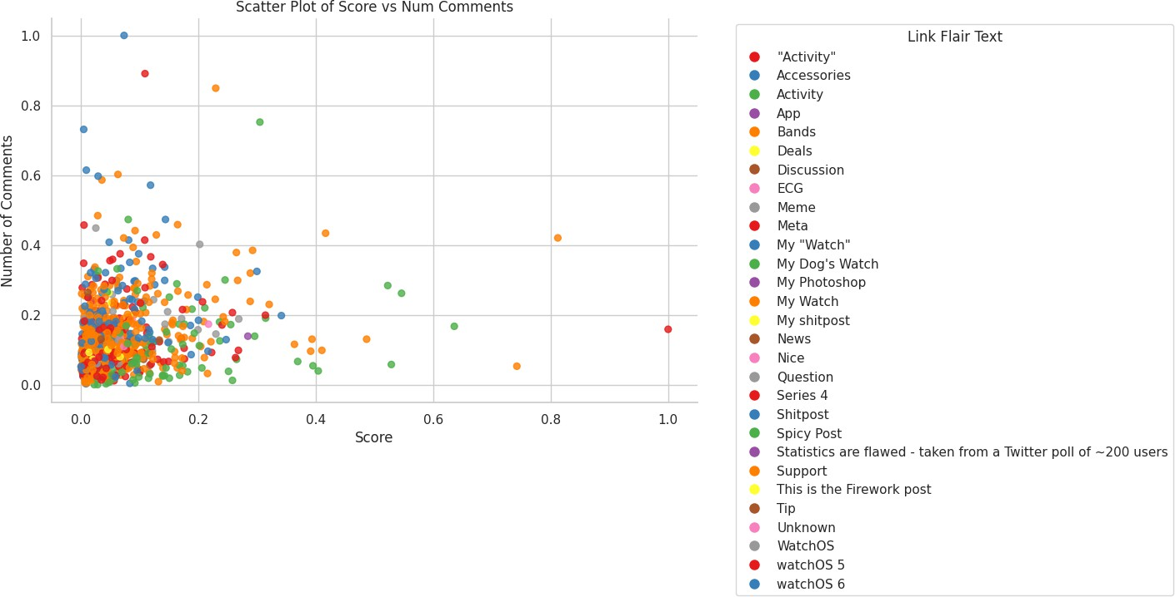

Fig 16: Scatter plot representing Intensity/ Occurrence of Subtopic (Link_flair_text) distribution of the posts



Highly connected groups:

From *fig16* even though Meme category is seeing lot of activity but still on network analysis of Highly connected authors of reddit post are communicating on the following topics –

Group 1: MyWatch, Activity, Bands. Group 2: Accessories, WatchOS Group 3: Discussion and Meme

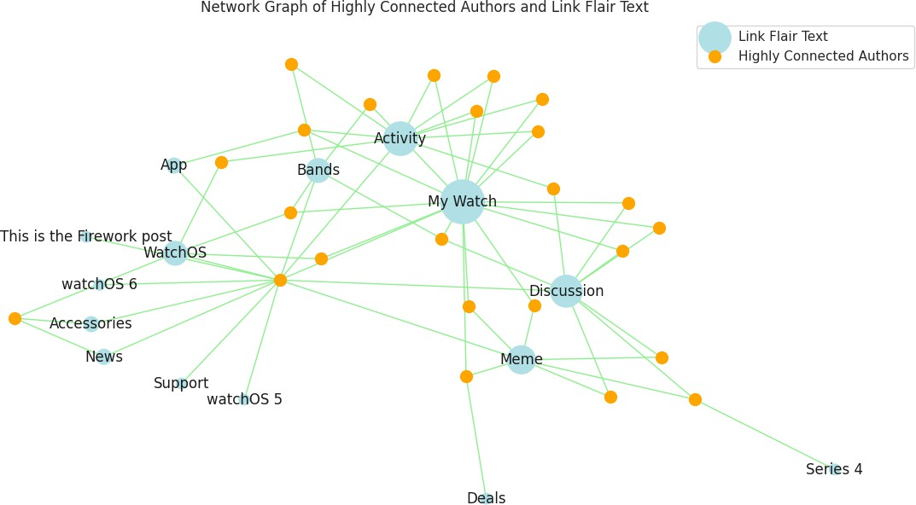

Fig 17: Network graph plot representing Connection of Subtopic (Link_flair_text) distribution of the posts amonst users

Most of conversations surrounding the AppleWatch are

My Watch closely linked with Activity, WatchOS, Discussion, Accessories and other community which is prevalent amongst users is Meme.



Clustering – K-Means

**Cluster 0:** Is seeing the least activity very few posts from this cluster are having high number of comments and even score is mostly lower with respect corresponding to the posts is also low.

**Cluster 1:** Is seeing the high activity but very few posts from this cluster are having high

score but number of comments on the posts of this cluster is high. This Clusters seems to talk more about buying, getting the watch and emphasizing more on the features of the watch.

**Cluster 2:** Is seeing the less activity then cluster1 and higher than cluster0. Very few posts from this cluster are having high number of comments and even score is mostly lower. This Cluster seem to discuss about Watch features, activity and discussions.

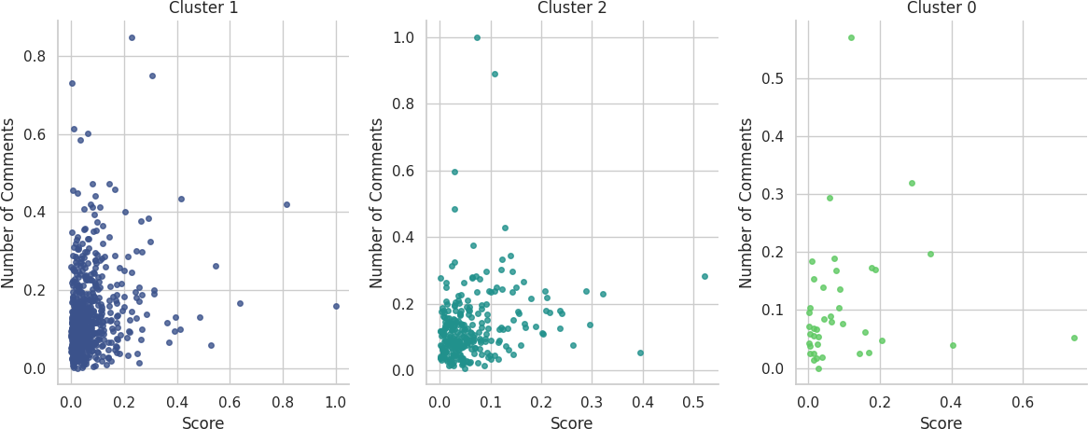

Fig 18,19,20: Scatter plot representing Number of Comments or Score representation for each cluster

Author Activity and Centrality: Users such as "willrb", "pcall1128", "m00rfinn" have consistent centrality measurements (degree, betweenness, and proximity centrality) and are active across multiple clusters (shown by varied values in the "cluster" column against their different post). This shows that they are active in the subreddit on a variety of issues.



Because to its high scores and activity in several clusters, "joeledition" stands out as an **influencer**. Compared to other users, the user's



Motivators such as "joeledition":

centrality metrics are comparatively greater, suggesting a notable presence and influence in

the network.

Users which belong to the same cluster typically have comparable centrality measurements.



Clusters and Centrality:

Users in cluster 1: "willrb," "pcall1128," and "m00rfinn", have similar centrality

measurements.

Users in cluster 0: "joeledition", "egocentric-video" and "dualjpg" are comparable.

Variation in Centrality Measures: Some users, such as "joeledition" and "egocentric- video," exhibit consistent centrality measures throughout clusters, whereas others, with changing measures across clusters, indicate diversified interaction on varied topics.

Visualisation is on the Top 50 based on scores against number of comments per cluster.

**Word Clouds – Based on Sentiment**

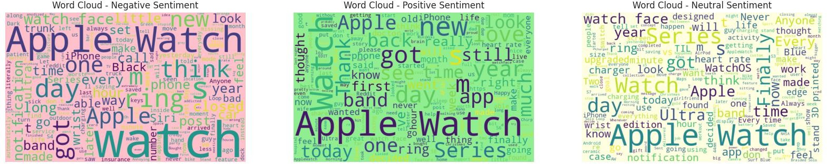

Fig 21,22,23: Word Cloud based on Sentiments

Positive Sentiment cloud is observed to be the biggest and most noticeable. This implies that there is an overall favourable attitude in the text under analysis.

Positive adjectives like "love", "best”,"easy", "great", "amazing" and "happy" serve to further accentuate this feeling.

Subjects and themes: A few terms that are associated with the functions and capabilities of the Apple Watch jump out, like "watch face," "activity," "workout," "battery," "health," and "fitness." This implies that the text probably talks about the Apple Watch and its features.

Key terms like as "Series," "Ultra," "band," and "case" designate particular Apple Watch models and accessories.

Remarkably, in the wordcloud, certain good feeling words coexist with negative ones. For example, "love" is placed next to "bugs" and "great" is placed close to "crash." This suggests that people have had varying experiences with the Apple Watch, enjoying certain features

while also running into problems.

**Negative Sentiment –** Yesterday, Apple Watch, notification, closed, service

**Positive Sentiment –** love, bands, Series, today, Update, saved, Thank, Apple Watch, thought



**Advice to the brand on their social media strategy based on this listening campaign**

In addition to increasing engagement, a listening campaign-driven social media strategy

provides a comprehensive and user-focused approach that fosters the development of a lively and supportive community around the AppleWatch subreddit. It presents Apple as a company that hears what its customers have to say, adapts, and changes as a result.

Based on listening campaign we can definitely tap on various facets on and about the product.

From brand image, issues encountered by the users, customer retention, attracting new customers, identifying customers cluster or tribes.

Listening to customers not only help us improve the way we do our business or develop products but also may give us some brilliant breakthrough ideas at times.



**Engagement Activities:**

Polls and Discussions with a Theme: Promote engagement by holding polls and conversations using a My Watch, Activity, and other popular category theme.

Ask users about their thoughts on upgrades, new features, and preferences to keep them engaged.

Hold engaging discussions on official handle of the Apple around negative sentiments which are surrounding features. Example – notification, battery etc

Content Created by Users: Encourage users to share their adaptations, advice, and Apple Watch experiences in order to build a feeling of community. Promote hashtags where we can reshare on Apple’s page is a new product is posted by a customer.

Regularly promote user-generated content to draw attention to the community's diversity.

As there are customer segments which are identified from the clusters, like fitness enthusiast, tech-savvy, health monitoring group (Old age or people with ill health) etc.

We can really promote users to share their stories to promote conversations around the brand.

Influencer Partnership: Work together with powerful users like as joeledition, mumpf1997, and egocentric-video to expand the audience for Apple Watch content.

Investigate collaborations for reviews, live debates, and exclusive material.

Activities of top users include discussions on apps, fitness-related topics, watch bands, accessories, and general watch-related discussions.

Top users based on upvote_ratio: Xx_Kellan_xX, Scolirk, ilikebirdsthatfly. High upvote ratios indicate positive perceptions from the community.

Top users based on scores: mattmurphy00, TheBrainwasher14, mnjustesen.

Tailored product Creation: The development of social media content for engagement that appeals to users is guided by insights gathered from the listening campaign. Posts become more effective as a result, and they are guaranteed to reflect the general consensus.



**Content Strategy:**

Adapt content to correspond with prevailing positive emotions, emphasizing terms such as bands, updates, love, and series.



Align with Positive Sentiments:

Emphasize user endorsements, success stories, and the good things of wearing an Apple Watch. Like a live saving potential of the watch which is mentioned by one the user who was 80-year-old. (This got highlighted in one of the initial study of data which was fetched from reddit and it stood out making a strong case for AppleWatch success story)

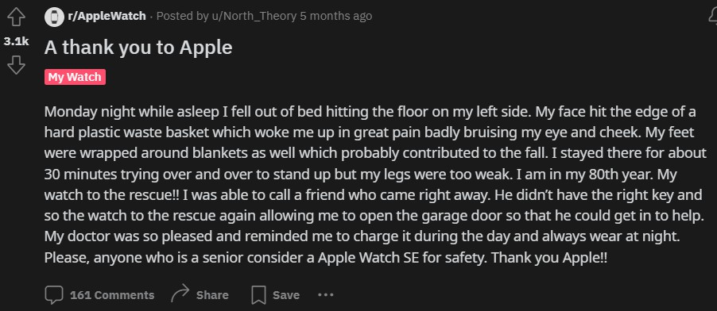

This could be turned in a very impactful advertisement to target the customers of that

segment and also make a strong case for children’s who are worried for the welfare of their parents.

Similar success storis can be pulled off from various segments data as posted by the users.

Address common user concerns transparently in posts or



Transparent Communication:

dedicated communication.

Provide solutions, updates, and timelines for addressing issues raised by the community. Have an effective and active dialog with the customers on the subreddit as this could potentially translate Apple as a brand to be perceived as a trustworthy and loyal to the customers as well.



**Community Building:**

Encourage a

welcoming and upbeat atmosphere in the subreddit to encourage constructive dialogue. Invite users to provide their varied experiences, suggestions, and difficulties.



Creating a Positive and Inclusive Environment to Foster Community:

Include recurring elements like "User Spotlight" to highlight community members and their inventive ways using Apple Watches.



Typical Elements:

Emphasize user accomplishments, artistic alterations, and inventive applications of the Apple Watch.



**Feedback Mechanism:**

Provide specific channels where users can report problems and offer comments and feedback.

Pay attention to what users have to say and thank them for their efforts to the community.



Channels for User Feedback:

Make use of continuous analysis insights to iteratively improve the social media approach.



Iterative Strategy Refinement:

To remain responsive, make adjustments in response to community dynamics and user feedback.

Apple makes data-driven judgments by analyzing user- generated content and sentiments. It guarantees that the community's true interests and



Making Decisions Based on Data:

preferences are reflected in the social media strategy.

By implementing these recommendations, Apple can create a vibrant and engaged

community within the AppleWatch subreddit, strengthen its brand presence, and leverage positive sentiments for long-term brand advocacy.



Brand Strategy Recommendations:

Resolve issues with negative feeling as soon as possible to stop more negativity.

Interact with prominent figures to capitalize on their beneficial influence inside the community.

Produce material centred around sentimentally positive terms to showcase the advantages of the Apple Watch.

To cater to different user interests that are reflected in distinct clusters and subtopics, diversify your material.

Keep an eye on and participate in conversations in high-activity groups to maintain community involvement.



**Competitive Advantage**

Brand can have a competitive advantage if it regularly monitors user discussions and competitor activity. It will enable the business to set itself apart according to the requirements and preferences of the user.

Implement continuous monitoring to stay updated on evolving sentiments, community dynamics, and emerging influencers.



Staying ahead in the game:

All the above can be implemented to improve Apple’s social media strategy and keep the community engaged and pleased.

# Graph/Visualizations – References

Fig 1: Word Cloud based on the data collected from subreddits Titles as provided by the users. – Page1

Fig 2: Word Cloud based on the data collected from subreddits Titles and text inside as provided by the users. – Page2 Fig 3: Bar Graph representing Number of posts made by individual users to identify Influencers and active users. – Page3

Fig 4: Bar Graph representing Number of Titles and Subclasses of Topics made by individual users to identify Influencers in particular area of expertise. – Page3

Fig 5: Word Cloud based number of comments made by users on subreddits. – Page4 Fig 6: Bar Graph representing Users v/s Number of comments – Page4

Fig 7: Table representing Normalised upvote_ratio. – Page5

Fig 8: Table representing Normalised score – Page5

Fig 9: Scatter plot representing Normalised score vs num_comments – Page 5

Fig 10,11,12: Bar Graph representing Sentiment distribution of the posts. It could be Positive, Negative or Neutral. – Page 6 Fig 13: Scatter plot representing Sentiment distribution of the posts. It could be Positive, Negative or Neutral. – Page 6

Fig 14: Bubble chart representing Intensity/ Occurrence of Subtopic (Link_flair_text) distribution of the posts – Page 7

Fig 15: Network graph plot representing Intensity/ Occurrence of Subtopic (Link_flair_text) distribution of the posts. –Page8 Fig 16: Scatter plot representing Intensity/ Occurrence of Subtopic (Link_flair_text) distribution of the posts – Page 8

Fig 17: Network graph plot representing Connection of Subtopic (Link_flair_text) distribution of the posts amongst users -- Page9

Fig 18,19,20: Scatter plot representing Number of Comments or Score representation for each cluster – Page 10 Fig 21,22,23: Word Cloud based on Sentiments – Page11

***************************************************************************